

# Task 1 – Pass Submission

Student Number: 104071453  
Student Name: Marco Giacoppo

### Pass 1a

* Reusability: once you create a query, you can save it for future use.
* Efficient Data Retrieval: queries are optimized for retrieving data from databases.
* Ease of Maintenance: if there is a need to modify the filtering conditions or add additional criteria, it can be done centrally in the query design.

### Pass 1b

### Pass 1c

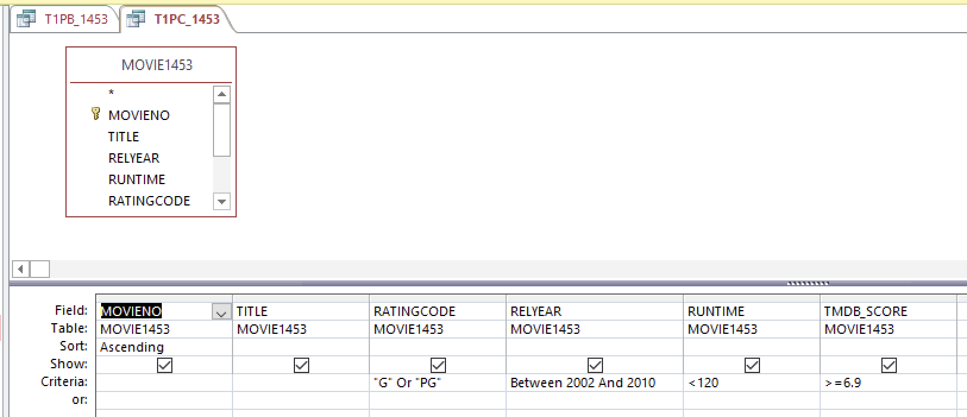

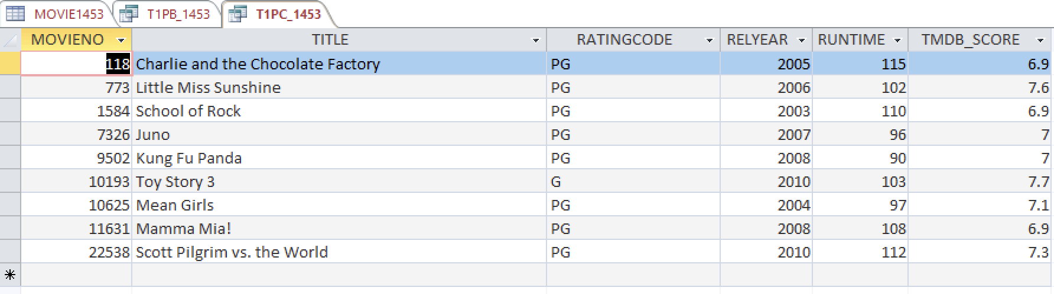

### Pass 1d

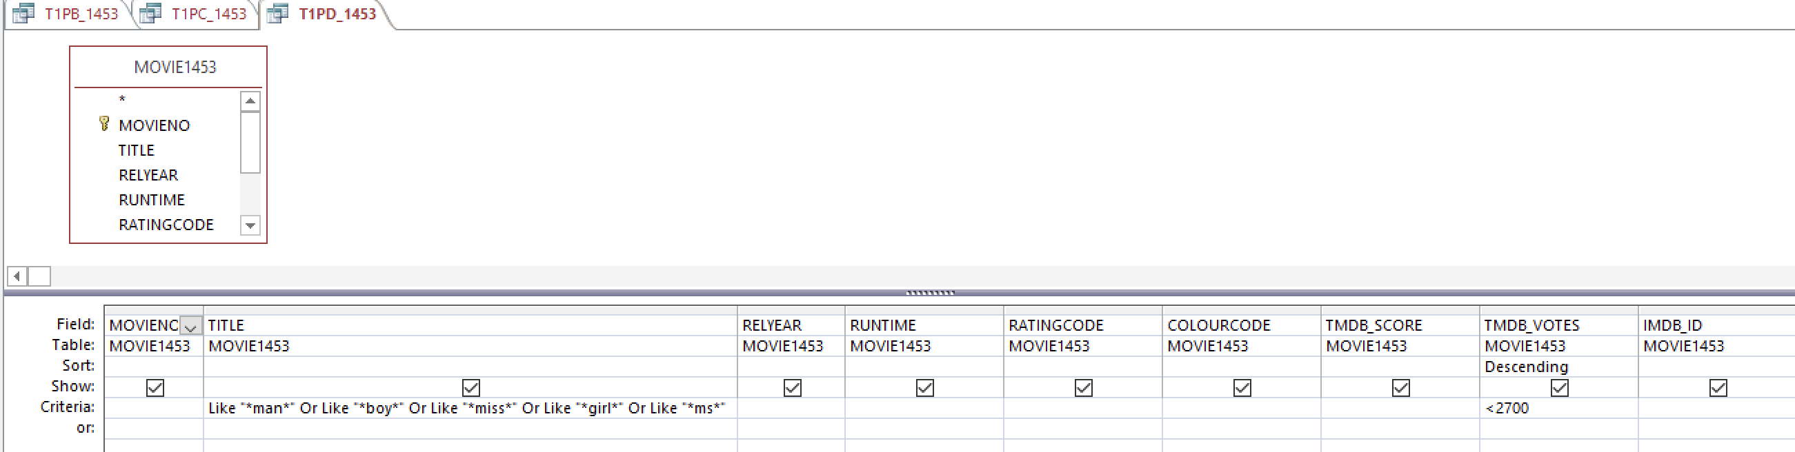

### Pass 1e

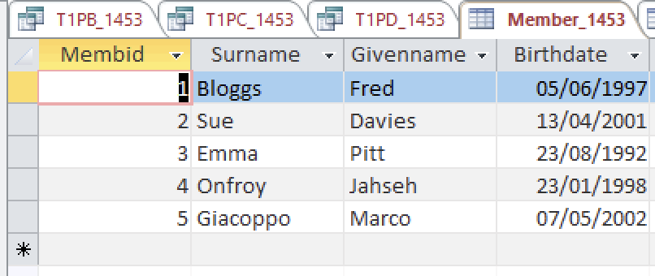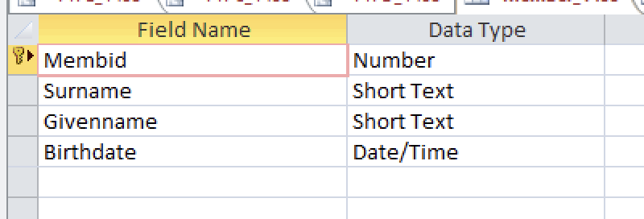

### Pass 1f

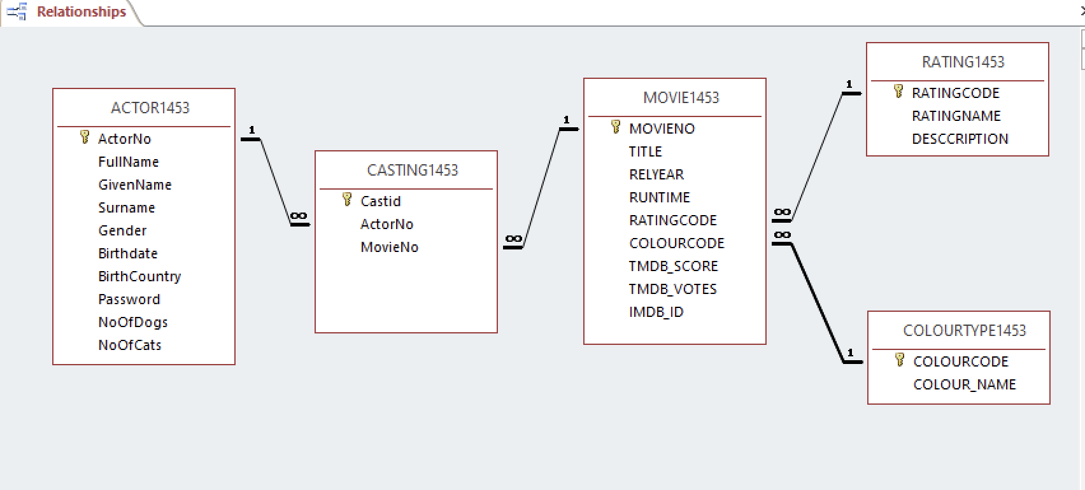

### Pass 1g

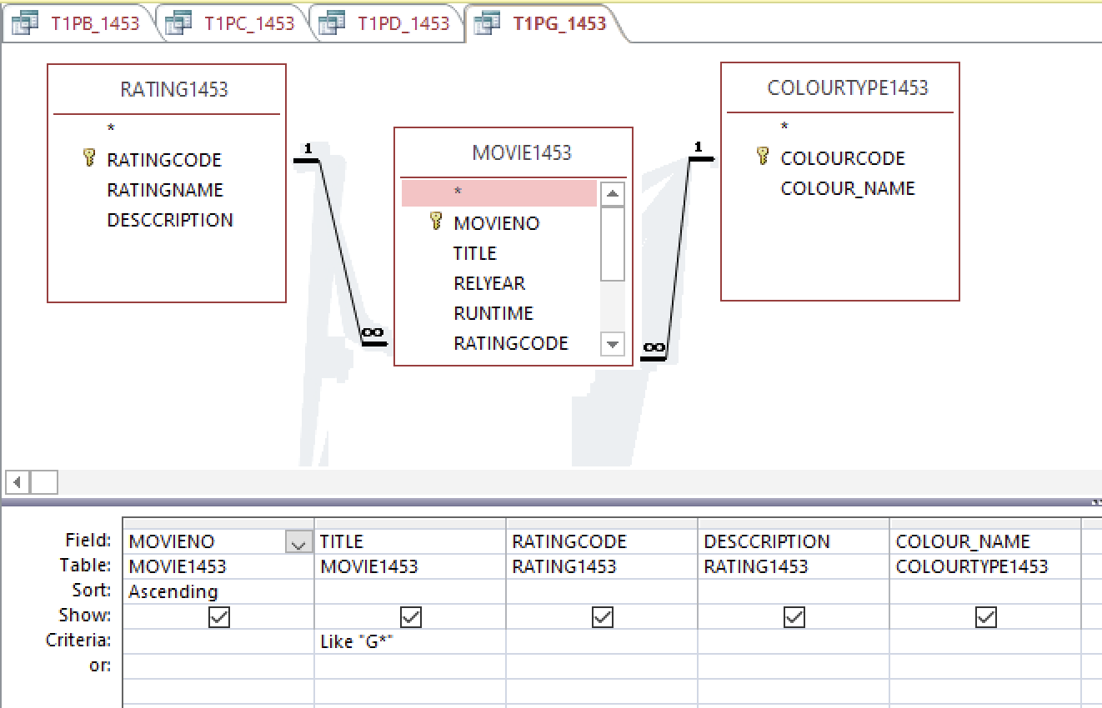

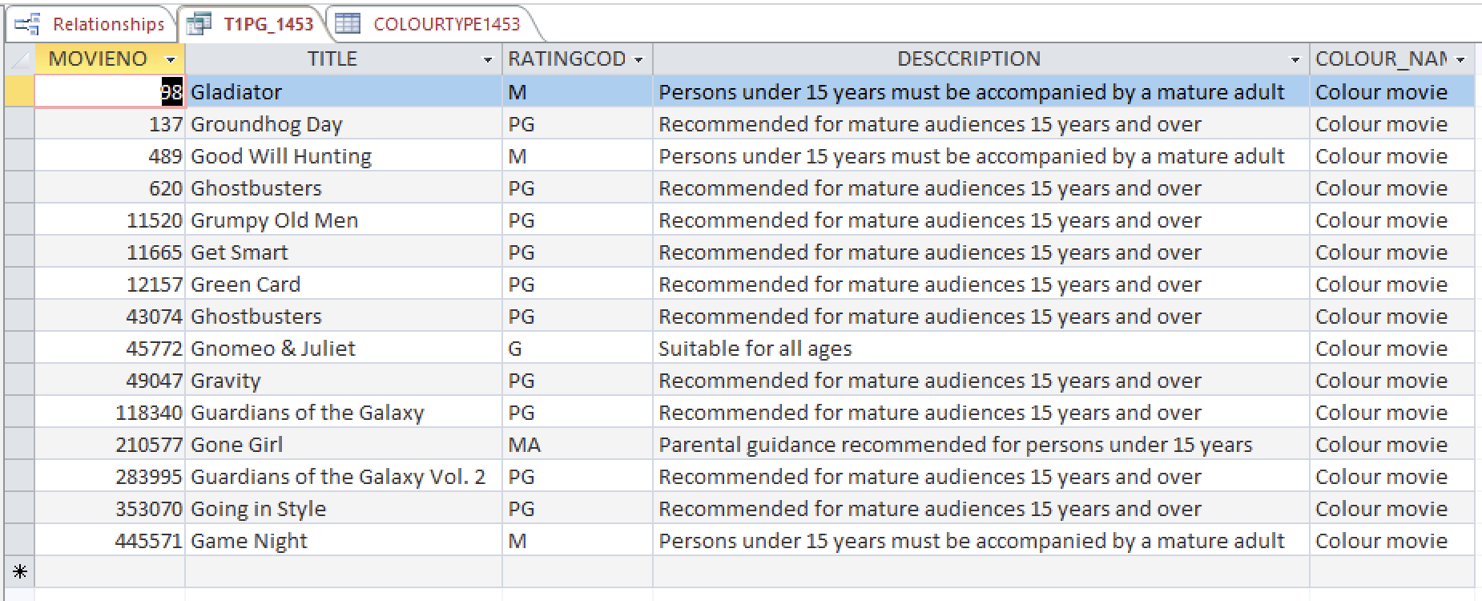

### Pass 1h

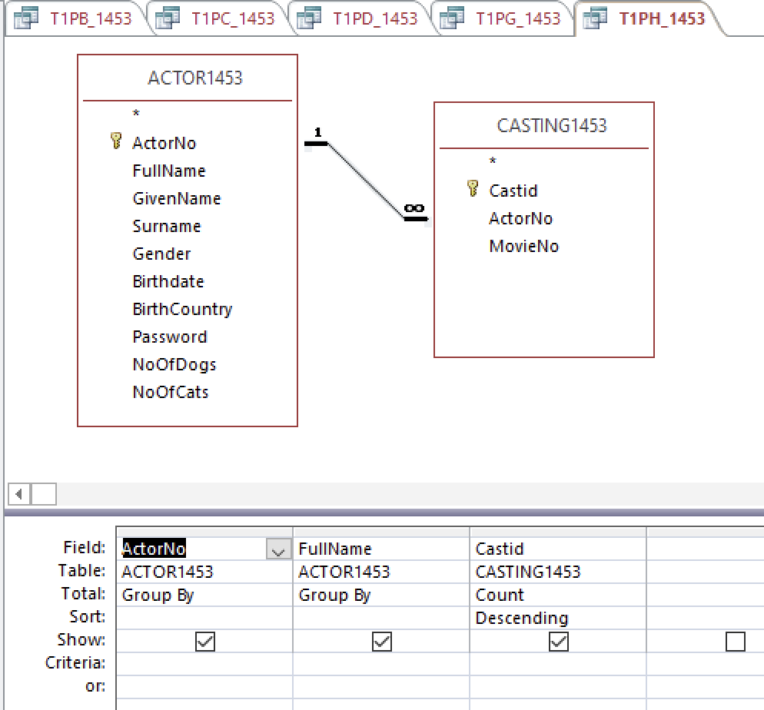

### Pass 1i

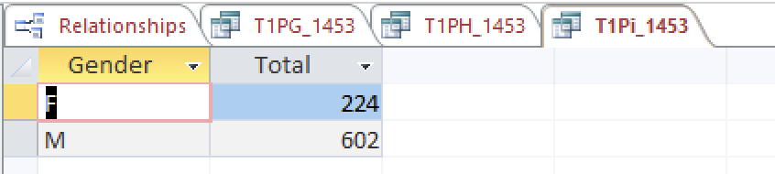

### Pass 1j

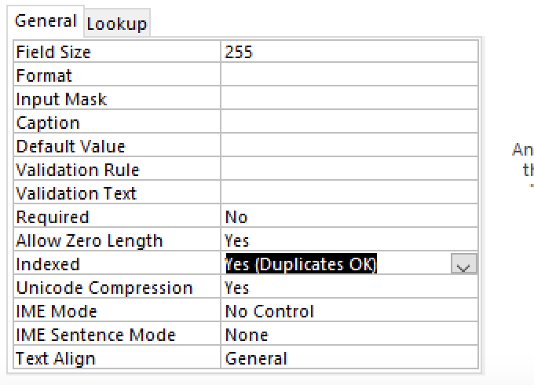

### Pass 1k

